Data Format

🌟 Definition
# Source: AI Source: Provided by: [Data Path: Persons Table -> ID Column: 1, Name_En Column: Motasem Essam] -> From: [ChatGPT] on [5/31/2026]
A Data Format is a standard way of organizing and structuring data so that it can be stored, read, processed, and exchanged between systems, applications, or humans.
It defines how information is written and understood.

🎯 Purpose of Data Formats
# Source: AI Source: Provided by: [Data Path: Persons Table -> ID Column: 1, Name_En Column: Motasem Essam] -> From: [ChatGPT] on [5/31/2026]
- Store data in a structured way
- Allow communication between systems (like APIs)
- Make data readable by humans and machines
- Ensure compatibility between software
- Enable data processing and analysis

🧩 Simple Idea
# Source: AI Source: Provided by: [Data Path: Persons Table -> ID Column: 1, Name_En Column: Motasem Essam] -> From: [ChatGPT] on [5/31/2026]
A data format is like a language for data — it tells computers how to write and read information correctly.

📚 Where Data Formats are Used
# Source: AI Source: Provided by: [Data Path: Persons Table -> ID Column: 1, Name_En Column: Motasem Essam] -> From: [ChatGPT] on [5/31/2026]
- 🌐 APIs (data exchange between client and server)
- 💾 Databases (storing structured data)
- 🧾 Configuration files (system settings)
- 📊 Spreadsheets and data analysis
- 🌍 Web development

📦 Common Data Formats

1. JSON (JavaScript Object Notation)
# Source: AI Source: Provided by: [Data Path: Persons Table -> ID Column: 1, Name_En Column: Motasem Essam] -> From: [ChatGPT] on [5/31/2026]
JSON.org
Used in APIs and web apps.
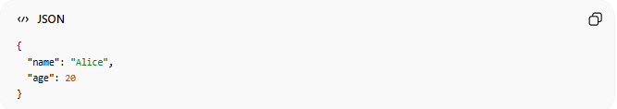
{
"name": "Alice",
"age": 20
}

2. XML (eXtensible Markup Language)
# Source: AI Source: Provided by: [Data Path: Persons Table -> ID Column: 1, Name_En Column: Motasem Essam] -> From: [ChatGPT] on [5/31/2026]
Used in enterprise systems and older APIs.
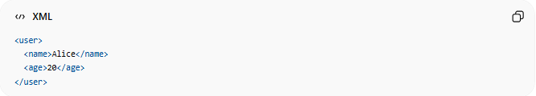
<user>
<name>Alice</name>
<age>20</age>
</user>

3. YAML (YAML Ain’t Markup Language)
# Source: AI Source: Provided by: [Data Path: Persons Table -> ID Column: 1, Name_En Column: Motasem Essam] -> From: [ChatGPT] on [5/31/2026]
YAML
Used in configuration files.
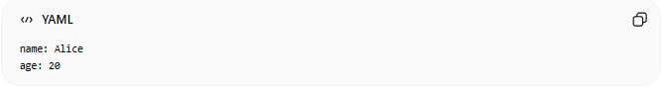
name: Alice
age: 20

4. CSV (Comma-Separated Values)
# Source: AI Source: Provided by: [Data Path: Persons Table -> ID Column: 1, Name_En Column: Motasem Essam] -> From: [ChatGPT] on [5/31/2026]
Used in spreadsheets and tables.
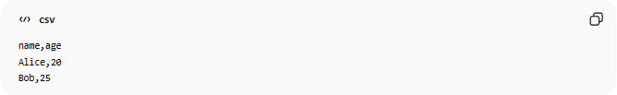
name,age
Alice,20
Bob,25

5. HTML (HyperText Markup Language)
# Source: AI Source: Provided by: [Data Path: Persons Table -> ID Column: 1, Name_En Column: Motasem Essam] -> From: [ChatGPT] on [5/31/2026]
Used to structure web pages.
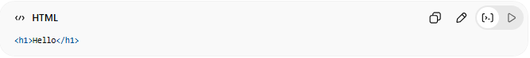
<h1>Hello</h1>

🔗 How Data Formats work in APIs
# Source: AI Source: Provided by: [Data Path: Persons Table -> ID Column: 1, Name_En Column: Motasem Essam] -> From: [ChatGPT] on [5/31/2026]
Client → API Request → Server → Data Format (JSON/XML) → Response → Client

🧠 Simple Analogy
# Source: AI Source: Provided by: [Data Path: Persons Table -> ID Column: 1, Name_En Column: Motasem Essam] -> From: [ChatGPT] on [5/31/2026]
Think of data formats like different ways of writing the same message:
- JSON = clean modern text 📦
- XML = formal letter 📜
- CSV = table in Excel 📊
- YAML = simple notes 📝
All carry information, just in different styles.

⚖️ Key Idea
# Source: AI Source: Provided by: [Data Path: Persons Table -> ID Column: 1, Name_En Column: Motasem Essam] -> From: [ChatGPT] on [5/31/2026]
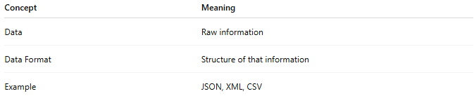
Concept | Meaning
Data | Raw information
Data Format | Structure of that information
Example | JSON, XML, CSV

🧭 Summary
# Source: AI Source: Provided by: [Data Path: Persons Table -> ID Column: 1, Name_En Column: Motasem Essam] -> From: [ChatGPT] on [5/31/2026]
A Data Format is a standardized way of structuring data so that computers and systems can store, read, and exchange information efficiently and correctly.

